Experiment 2: Apply Gaussian Blur
Aim: To read an image in Python and apply Gaussian Blur to reduce noise and smooth the image.
Procedure:
- Import the OpenCV library.
- Read the input image.
- Apply Gaussian Blur using cv2.GaussianBlur().
- Display the original and blurred images.
- Close the display windows.
Program:
import cv2
img = cv2.imread(r"D:\Amrita\Pictures\Screenshots\image.png")
blur = cv2.GaussianBlur(img, (5, 5), 0)
cv2.imshow("Original Image", img)
cv2.imshow("Blurred Image", blur)
cv2.waitKey(0)
cv2.destroyAllWindows()
Input:
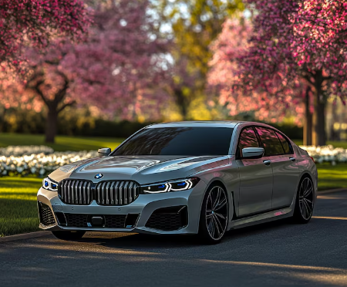
Output:
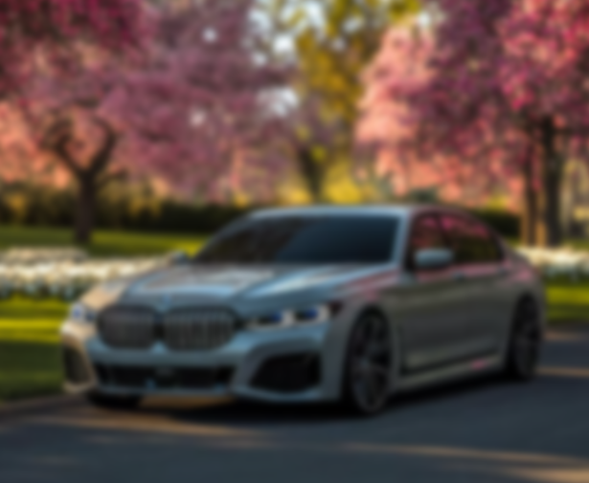
Result:
Gaussian Blur was successfully applied to the input image, producing a smoother image with reduced fine detail and noise.

